

This message from the Records and Registration Office provides you with some VERY important information that applies to ALL students during the 2018 Spring Quarter and 2018 Spring Semester, including:

1. 1-Minute Survey
2. Add and Drop Deadlines
3. Transcripts and Enrollment Verification Requests
4. 2018 Summer and Fall Registration
5. Graduation Applications
6. FERPA Rights

**1-Minute Survey**

Please go to this site <https://sites.ewu.edu/records-and-registration-forms/survey-beginning-of-term-email> and complete a brief survey regarding this Beginning of Term email.

**2018 Spring Quarter Deadlines**

|  |  |  |  |  |  |  |  |  |
| --- | --- | --- | --- | --- | --- | --- | --- | --- |
| **2018 SPRING QUARTER DATES** | | | **ONLINE**  **REGISTRATION** | | **GRADE & TUITION**  **REFUND DEADLINES**  **(LAST DAY TO DROP)** | | | |
| **DESCRIPTION OF TERM** | **START** | **END** | **ADD**  **DEADLINE** | **DROP**  **DEADLINE** | **NO "W"**  **100%\*** | **NO "W"**  **50%\*\*** | **"W"**  **50%** | **"W"**  **0%\*\*\*** |
| Full Term | 4/2/18 | 6/15/18 | 4/4/18 | 4/9/18 | 4/9/18 | 4/13/18 | 5/1/18 | 5/18/18 |
| First Half Spring | 4/2/18 | 5/4/18 | 4/4/18 | 4/6/18 | 4/6/18 |  | 4/13/18 | 4/20/18 |
| Second Half Spring | 5/7/18 | 6/8/18 | 5/9/18 | 5/11/18 | 5/11/18 |  | 5/18/18 | 5/25/18 |

No “W” = Will not receive withdrawal grade on transcript

“W” = Will receive withdrawal grade on transcript

100% = 100% tuition refund

50% = 50% tuition refund

0% = 0% tuition refund

*Dropping a course after this date will result in a late drop fee ($31.89) per course dropped

**Adding a course after this date will result in a late add fee ($31.89) per course added

***Cannot withdraw from an individual course after this date

**2018 Spring Semester Deadlines**

|  |  |  |  |  |  |  |  |  |
| --- | --- | --- | --- | --- | --- | --- | --- | --- |
| **2018 SPRING SEMESTER DATES** | | | **ONLINE**  **REGISTRATION** | | **GRADE & TUITION REFUND**  **DROP DEADLINES**  **(LAST DAY)** | | | |
| **DESCRIPTION OF TERM** | **START** | **END** | **ADD**  **DEADLINE** | **DROP**  **DEADLINE** | **NO "W"**  **100%\*** | **NO "W"**  **50%\*\*** | **"W"**  **50%** | **"W"**  **0%\*\*\*** |
| Full Term | 1/8/18 | 5/4/18 | 1/10/18 | 1/16/18 | 1/16/18 | 1/22/18 | 2/6/18 | 3/23/18 |

No “W” = Will not receive withdrawal grade on transcript

“W” = Will receive withdrawal grade on transcript

100% = 100% tuition refund

50% = 50% tuition refund

0% = 0% tuition refund

*Dropping a course after this date will result in a late drop fee ($31.89) per course dropped

**Adding a course after this date will result in a late add fee ($31.89) per course added

***Cannot withdraw from an individual course after this date

**Transcripts and Enrollment Verifications**

Transcripts and Enrollment Verifications must be requested online:

1. To order an **official transcript**, login to the **myEWU Portal** and click on the **Student** tab at the top. Scroll down to the **EagleNET** window and select Student > Student Records > Order Official Transcript. The fee for this service is $12.08.
2. To view an **unofficial** record of your transcript, login to the **myEWU Portal** and click on the **Student** tab at the top. Scroll down to the **Academic Profile** window and click on **Transcript**. There is no charge to view this record.
3. To request an **enrollment verification** (for loan providers, scholarships, insurance companies, employers, etc), login to the **myEWU Portal** and click on the **Student** tab at the top. Scroll down to the **EagleNET** window and select Student > Student Records > Request EWU Enrollment Verification. There is no charge for this service.

**2018 Summer Registration**

Summer registration will begin on Monday, April 23.

**2018 Fall Priority Registration**

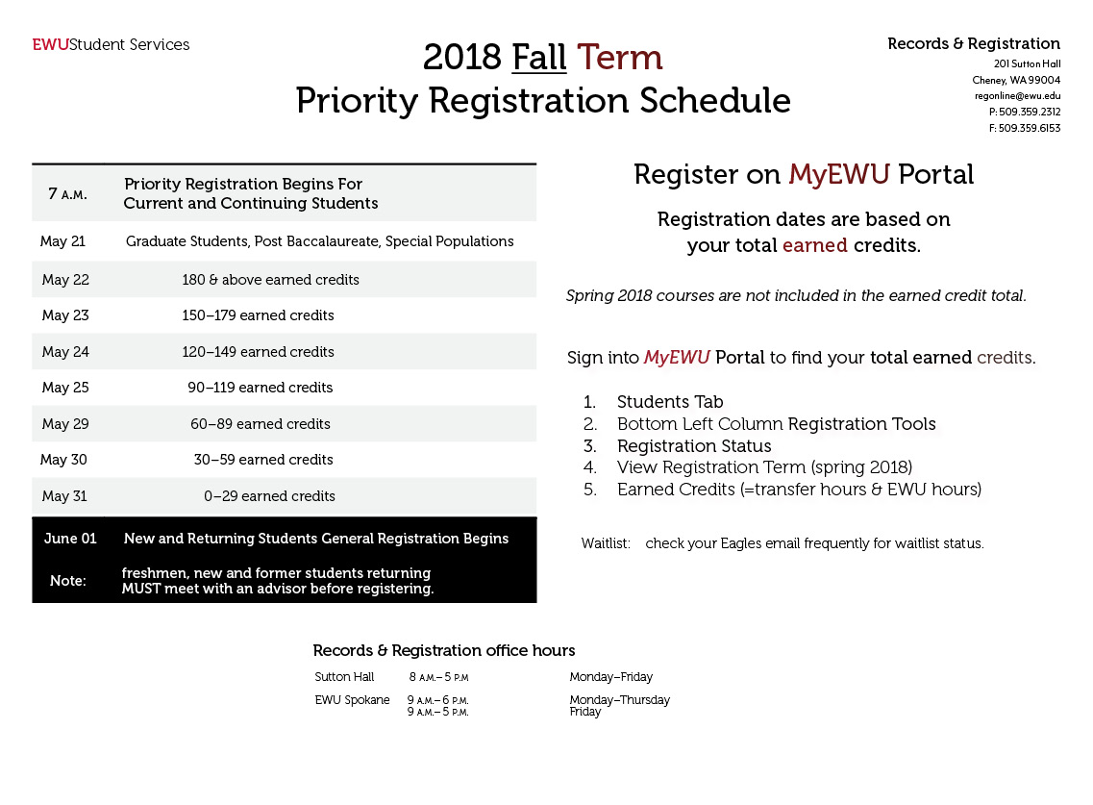

May 21, 2018 – Continuing Graduate & Post Baccalaureate Students, Special Populations

May 22, 2018 – 180 & above earned credits

May 23, 2018 – 150-179 earned credits

May 24, 2018 – 120-149 earned credits

May 25, 2018 – 90-119 earned credits

May 29, 2018 – 60-89 earned credits

May 30, 2018 – 30-59 earned credits

May 31, 2018 – 0-29 earned credits

June 1, 2018 – All New and Returning Students General Registration Begins

**Graduation Application**

For complete information regarding how to apply to graduate, how to pay for the application, and when to apply for graduation, please visit our **Graduation** page at <https://sites.ewu.edu/records-and-registration/graduation>. The Fall 2018 application deadline is May 11, 2018.

**FERPA Rights**

The Family Educational Rights and Privacy Act (FERPA) affords eligible students certain rights with respect to their education records. (An "eligible student" under FERPA is a student who is 18 years of age or older or who attends a postsecondary institution at any age.) These rights include:

1. The right to inspect and review the student's education records within 45 days after the day Eastern Washington University receives a request for access. A student should submit to the Records and Registration office a written request that identifies the record(s) the student wishes to inspect. The school official will make arrangements for access and notify the student of the time and place where the records may be inspected. If the records are not maintained by the school official to whom the request was submitted, that official shall advise the student of the correct official to whom the request should be addressed.
2. The right to request the amendment of the student’s education records that the student believes is inaccurate, misleading, or otherwise in violation of the student’s privacy rights under FERPA.

A student who wishes to ask the school to amend a record should write the school official responsible for the record, clearly identify the part of the record the student wants changed, and specify why it should be changed.

If Eastern Washington University decides not to amend the record as requested, Eastern Washington University will notify the student in writing of the decision and the student’s right to a hearing re­garding the request for amendment. Additional information regarding the hearing procedures will be provided to the student when notified of the right to a hearing.

1. The right to provide written consent before Eastern Washington University discloses personally identifiable information (PII) from the student's education records, except to the extent that FERPA authorizes disclosure without consent.

Eastern Washington University discloses education records without a student’s prior written consent under the FERPA exception for disclosure to school officials with legitimate educational interests. A school official is typically includes a person employed by Eastern Washington University in an administrative, supervisory, academic, research, or support staff position (including law enforcement unit personnel and health staff); a person serving on the board of trustees; or a student serving on an official committee, such as a disciplinary or grievance committee. A school official also may include a volunteer or contractor outside of the Eastern Washington University who performs an institutional service of function for which the school would otherwise use its own employees and who is under the direct control of the school with respect to the use and maintenance of PII from education records, such as an attorney, auditor, or collection agent or a student volunteering to assist another school official in performing his or her tasks. A school official typically has a legitimate educational interest if the official needs to review an education record in order to fulfill his or her professional responsibilities for Eastern Washington University.

1. The right to file a complaint with the U.S. Department of Education concerning alleged failures by Eastern Washington University to comply with the requirements of FERPA. The name and address of the office that administers FERPA is:

Family Policy Compliance Office  
U.S. Department of Education  
400 Maryland Avenue, SW  
Washington, DC  20202