Which Of These 4 Communication Styles Are You?

Mark Murphy , CONTRIBUTORI solve the “people pain points” that keep leaders awake at night. Opinions expressed by Forbes Contributors are their own.
What’s your communication style? You have a particular style of communicating, of course, but do you know what it is, including its strengths and weaknesses, and how it compares to the styles of others? Over the past two decades of research, my team and I have found that there are four fundamental communication styles: Analytical, Intuitive, Functional and Personal.
No one communication style is inherently better than another. But picking the wrong style for a particular audience, whether it’s one person or a thousand, shuts down listening and can spell trouble. Learning to build flexibility around your preferred style allows others to more successfully hear the important things you need to communicate. (There’s a free communication styles assessment to assess your preferred style.)
One major philosophical difference that separates the four communication styles is the extent to which you communicate with emotions or with data. For example, would you say something like ‘I feel like we’re off to a good start this quarter’ (emotions). Or would you say ‘this quarter sales are up by 7.2%’ (data).
Another major philosophical difference is the extent to which you communicate in a linear way (e.g. do you like to start with A then B then C then D, all the way to Z) or in a freeform way (e.g. do you like to skip over most of the details and jump right to Z).
Of course, there’s a lot more to the four communication styles than just these two philosophical differences. But as a starting point, these are emblematic of the myriad ways that we like to communicate.
Here are descriptions of each of the four communication styles (Analytical, Intuitive, Functional and Personal). See which style you think resonates with you, and take the communication styles assessment to corroborate your intuition. (https://www.leadershipiq.com/blogs/leadershipiq/39841409-quiz-whats-your-communication-style)
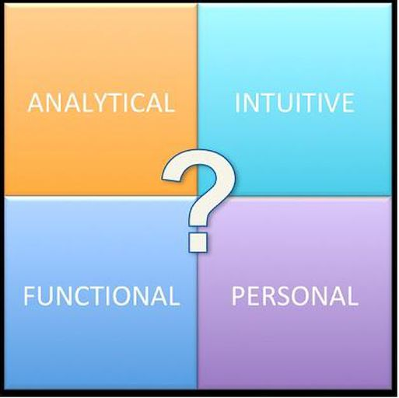

The Analytical Communicator
As an Analytical communicator, you like hard data, real numbers, and you tend to be suspicious of people who aren’t in command of the facts and data. You typically like very specific language and dislike vague language. For example, when someone tells you ‘sales are positive’ you’re likely to think ‘what does positive mean? 5.2% or 8.9%? Give me a number!’ And those with an Analytical communication style often have little patience for lots of feeling and emotional words in communication.
One big plus of having an Analytical communication style is that because you like communication to be fairly unemotional, you’re often able to look at issues logically and dispassionately. This means others tend to see you as having high-levels of data and informational expertise.
The potential downside of having an Analytical communication style is that you may strike certain people as being cold or unfeeling. For example, when interacting with people like Personal communicators (who tend to like warm and chatty personal relationships), it’s possible for Analytical communicators to get irritated and terse. This sometimes has negative political and relational consequences.
The Intuitive Communicator
As an Intuitive communicator, you like the big picture, you avoid getting bogged down in details, and you cut right to the chase. You don’t need to hear things in perfect linear order but prefer instead a broad overview that lets you easily skip right to the end point. For example, some people, like Functional communicators, will tell you things step-by-step (they start with A, then go to B, then C, then D, then E, etc.). But this can drive you nuts; you’d rather jump right to Z.
One big plus of having an Intuitive communication style is that your communication is quick and to the point. You don’t get stalled by needing too many details, and you’re comfortable with big ideas and out-of-the-box thinking. Because you’re good with thinking big, you can also enjoy challenging convention.
The potential downside of having an Intuitive communication style is that you may not always have enough patience when you’re in a situation that actually requires getting into nitty-gritty detail (and you may risk missing an important point). Typically, Intuitive communicators have the most difficulty dealing with Functional communicators (those are the 'process-driven' people, they’re very methodical, walk through things step-by-step, and like nitty-gritty detail).
The Functional Communicator
As a Functional communicator, you like process, detail, timelines and well-thought-out plans. You like to communicate things in a step-by-step fashion so nothing gets missed. By contrast, there are some people, like the Intuitive communicators, who like to skip all the detail and just jump right to the end. But this can drive you nuts; especially when you think about all the important bits of information the Intuitive person is potentially missing.
One big plus of having a Functional communication style is that your communication generally hits all the details and nothing gets missed. When you’re on a team, people will often turn to you to be the implementer, because they have confidence in your love of process and detail. And because you’re focused on things like process and detail, you’re the person who is typically asked to play Devil’s Advocate.
The potential downside of having a Functional communication style is that you may risk losing the attention of your audience, especially when you’re talking to Intuitive communicators (those are the 'big picture' people who skip to the end and don't get bogged down in too much detail).
The Personal Communicator
As a Personal communicator, you value emotional language and connection, and use that as your mode of discovering what others are really thinking. You find value in assessing not just how people think, but how they feel. You tend to be a good listener and diplomat, you can smooth over conflicts, and you’re typically concerned with the health of your numerous relationships.
One big plus of having a Personal communication style is that your communication allows you to build deep personal relationships with others. People will often turn to you as the ‘glue’ that holds groups together. And you’re typically able to pick-up ‘vibes’ that others may miss because you’re attuned to the emotional aspect of communication.
The potential downside of having a Personal communication style is that you may occasionally be derided as ‘touchy-feely.’ For example, when dealing with Analytical communicators (people who like data, hard numbers, logical discussions, and dislike that 'warm-and-fuzzy' stuff), it’s possible for Personal communicators to become exasperated and emotionally upset.
Conclusion
So, what’s your communication style? As I said at the beginning, one style isn’t better than another. The key is to first understand your own particular communication style so you can match your communication style to that of your audience. Whether you’re speaking with your boss, a small sales meeting, your employees or an audience of thousands, matching your communication styles to the folks you need to hear your words is an essential step to effective communication.
Mark Murphy is NY Times bestselling author, Founder of Leadership IQ, a sought-after leadership training speaker, and creator of the leadership styles assessment. https://www.forbes.com/sites/markmurphy/2015/08/06/which-of-these-4-communication-styles-are-you/#1ae96b983adb

